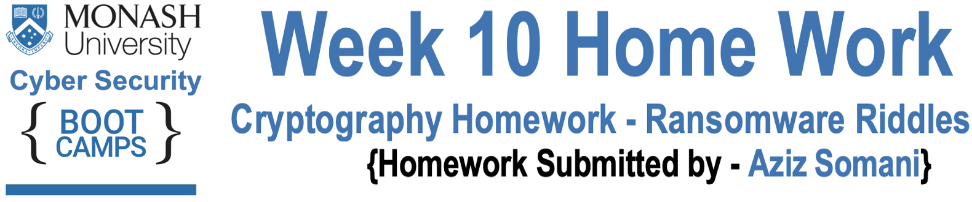

 **Riddle - 1**

**Answer: -** To solve Riddle 1, as it’s written in the photo first clue caesar would be 8. So, the algorithm to encryption is 8 and then I have applied this method in reverse to determine the ozcjmz text and the first letter for O was G.

After this I have use used an algorithm that converts plaintext into ciphertext to determine the plaintext of an encrypted text, therefor first I copied encrypter.py python file from cryptographic attacks activity and O to G alphabetically distant count was 20 so I have edited the encrypter.py file and I changed last printing line caesar text to 20 and run the encrypter.py and got the encrypted password and the password was **‘gruber’** and entered the password into riddle 1 and got the **6skd8s**.

**Password - gruber**

**Congrats, you have solved the first riddle, Your first key is: 6skd8s.**

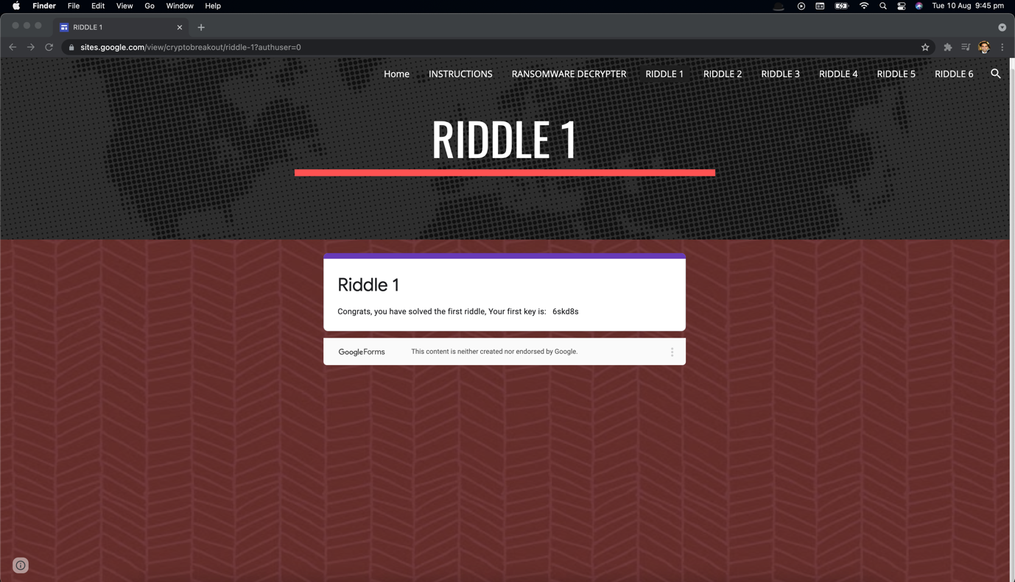



 **Riddle - 2**

**Answer: -** To Solve Riddle 2, I opened CyberChef website into browser and select converts a binary string back into its raw form recipe, so once I converted 01000111 01100101 01101110 01101110 01100101 01110010 01101111 and I finally decode binary message and the decode is Gennero.

**Decode Message - Gennero**

**Congrats for solving the second riddle, the key is: cy8snd2**

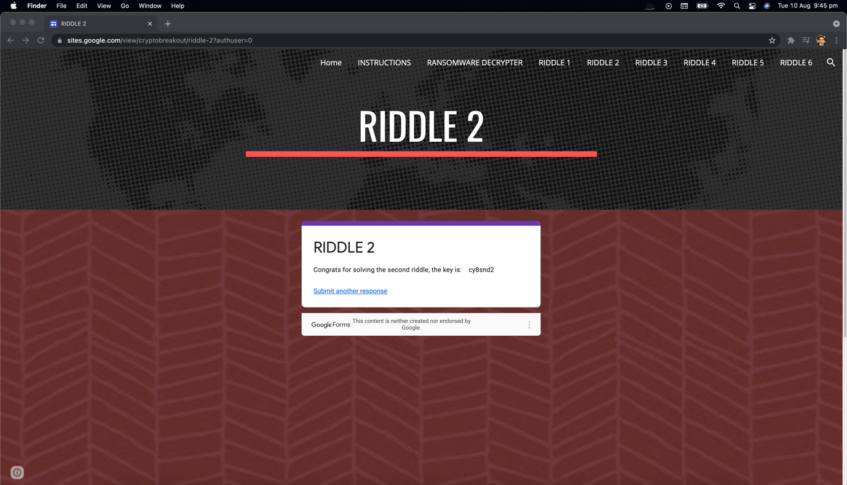



 **Riddle - 3**

**Answer: -** To solve Riddle 3, I used openssl and options -pbkdf2 -nosalt -aes-256-cbc -base64 and to decrypt cipher text option -d. Below is the command to get the password.

**"openssl enc -pbkdf2 -nosalt -aes-256-cbc -in plainmessage.txt.enc -d -base64 -K 5284A3B154D99487D9D8D8508461A478C7BEB67081A64AD9A15147906E8E8564 -iv 1907C5E255F7FC9A6B47B0E789847AED"**

**Below is the command syntax: -**

* `openssl` initializes the OpenSSL program.
* `enc` stands for _encryption_.
* `-pbkdf2` specifies the encryption key type.
* `-nosalt` specifies that salting will not be applied.
* `-aes-256-cbc` the type of cipher used.
* `-in plainmessage.txt` is the input file that we will be encrypting.
* `-d` specifies decryption.
* `-base64` specifies completing the encryption in a text format.
* `-K 5284A3B154D99487D9D8D8508461A478C7BEB67081A64AD9A15147906E8E8564` specifies the key and the key value.
* `-iv 1907C5E255F7FC9A6B47B0E789847AED` specifies the IV and the IV value.

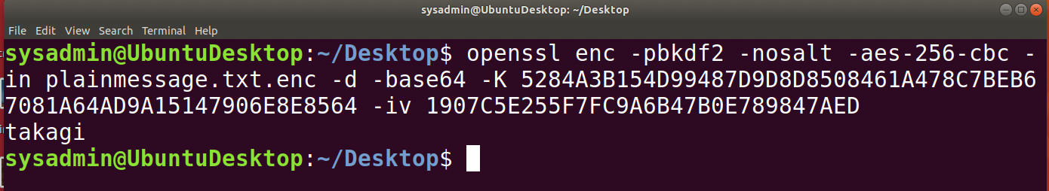

**Password – takagi**

**Congrats on Solving Riddle number 3, here is your key: ud6s98n**



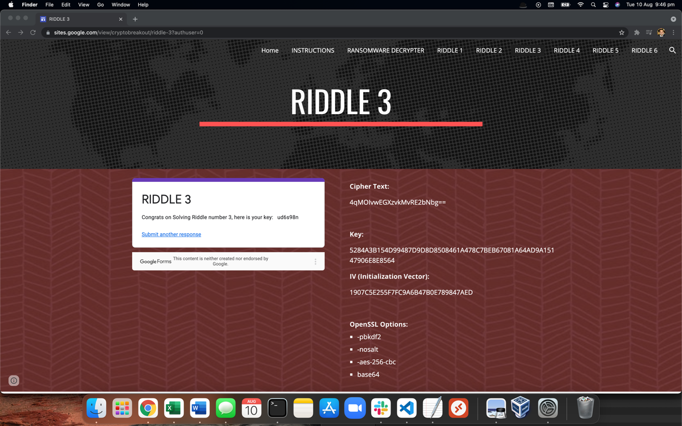



 **Riddle - 4**

**Answer: -** Below are the answers for following questions.

1. What would jack use to send an encrypted message to Jill?

**Answer: -** Jill's Public Key

1. What would Jill use to decrypt Jacks message? *

**Answer: -** Jill's Private Key

1. Jack and Jill invited Bob, Alice, Tim and Peter along to exchange some messages. How many keys would they all need for asymmetric vs symmetric encryption? *

**Answer: -** 12 Asymmetric and 15 Symmetric

1. Tim just sent an encrypted message to one of his friends, which of the following keys did he likely use to encrypt the message *

**Answer: -** Alice's Public Key

**Congrats! The Key is: 7gsn3nd2**

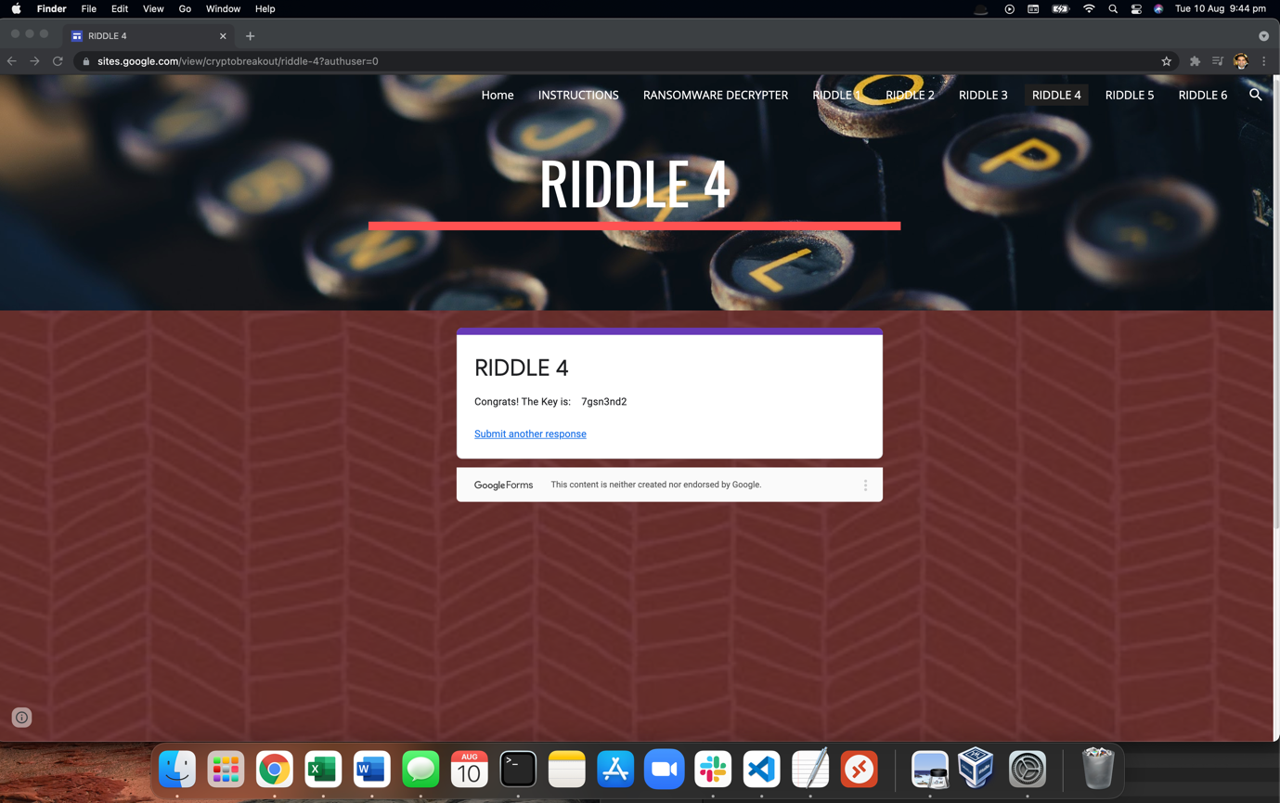



 **Riddle - 5**

**Answer: -** To solve Riddle 5, I have placed it into a file called `hash.txt` by running this command - **“echo 3b75cdd826a16f5bba0076690f644dc7 > hash.txt”.**

After this I have run Hashcat command – “**hashcat -m 0 -a 0 -o solved.txt hash.txt /usr/share/wordlists/rockyou.txt –force”**

**Below is the command syntax: -**

* `hashcat`: The command to execute Hashcat
* `-m 0`: Uses the MD5 hash
* `a 0`: Applies a dictionary attack
* `-o solved.txt`: Creates an output file called `solved.txt`
* `hash.txt`: The input file of the hash 3b75cdd826a16f5bba0076690f644dc7.
* `/usr/share/wordlists/rockyou.txt`: The location of the wordlist.
* `--force`: Overrides any small errors that may occur.

After this I open solved.txt file and found out the password for riddle 5.

**Password – argyle**

**Congrats on solving Riddle number 5, Here is your key: ajy39d2**

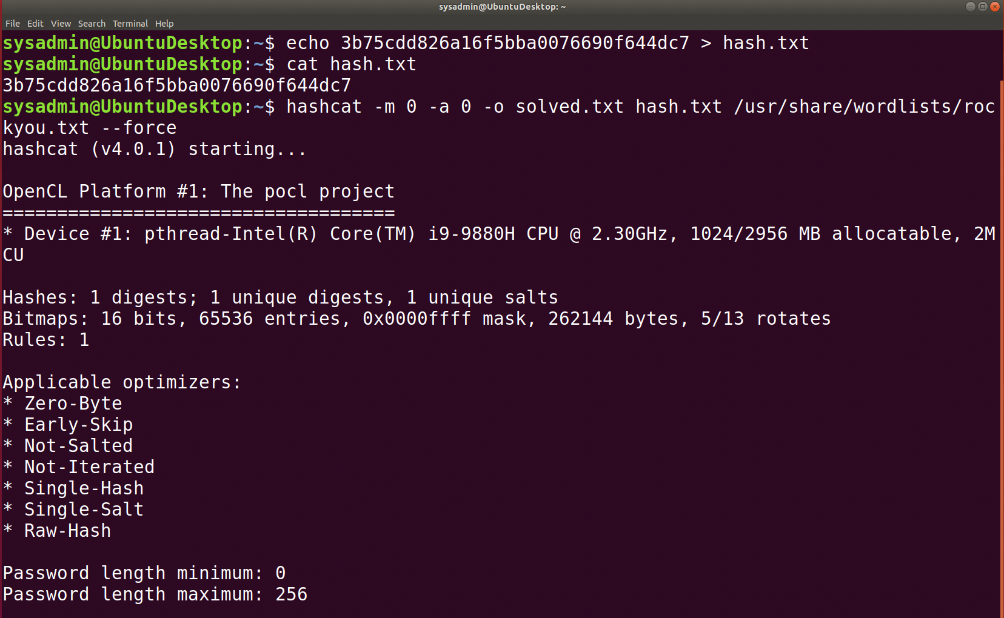

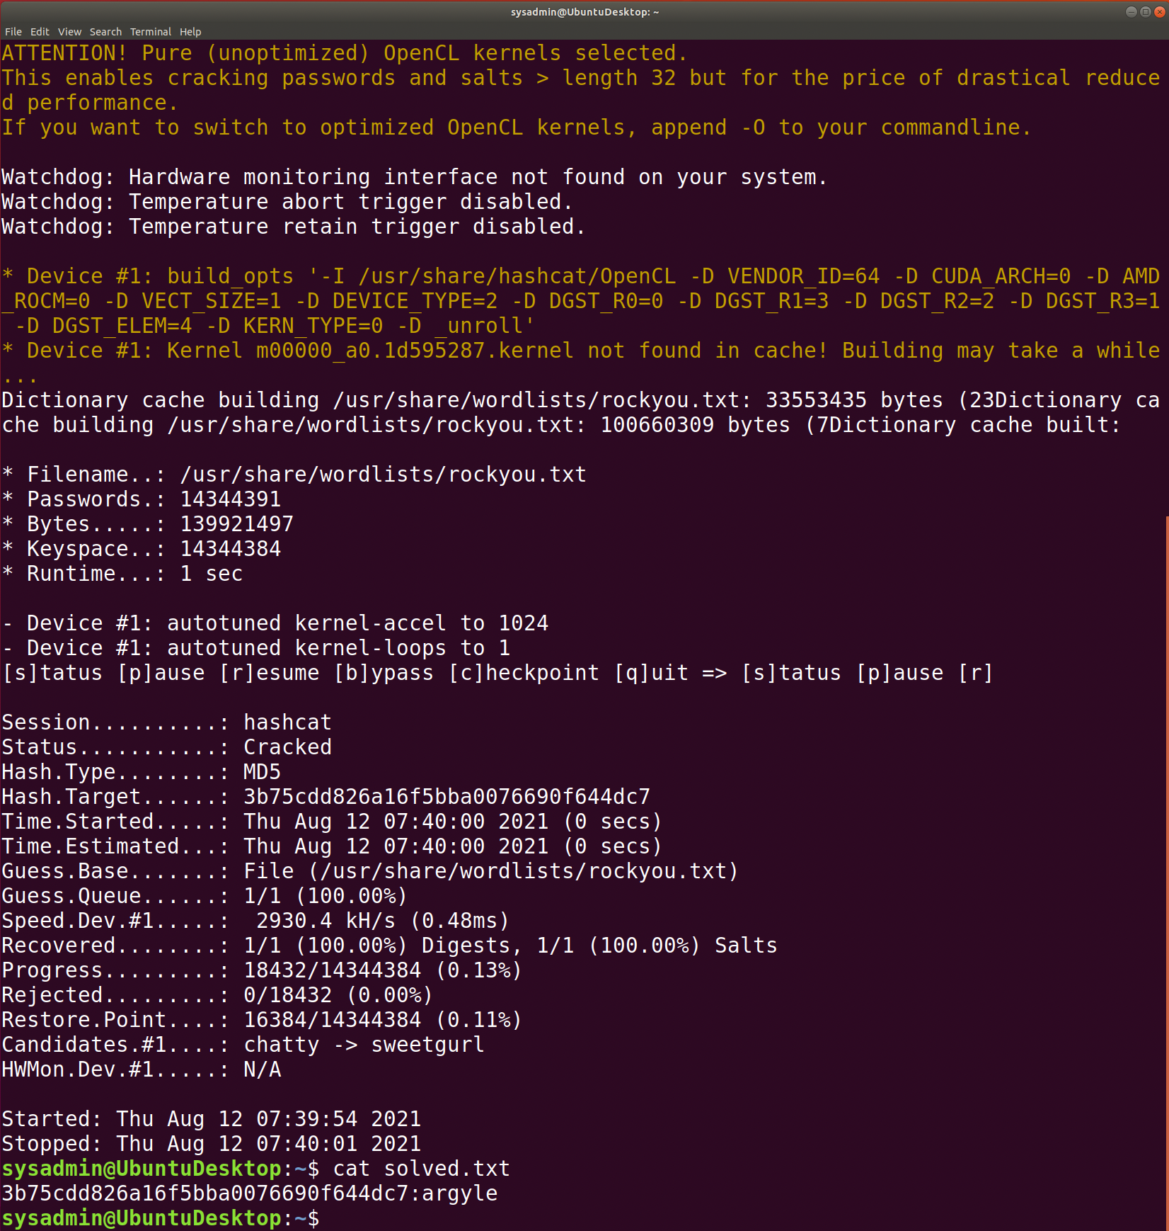

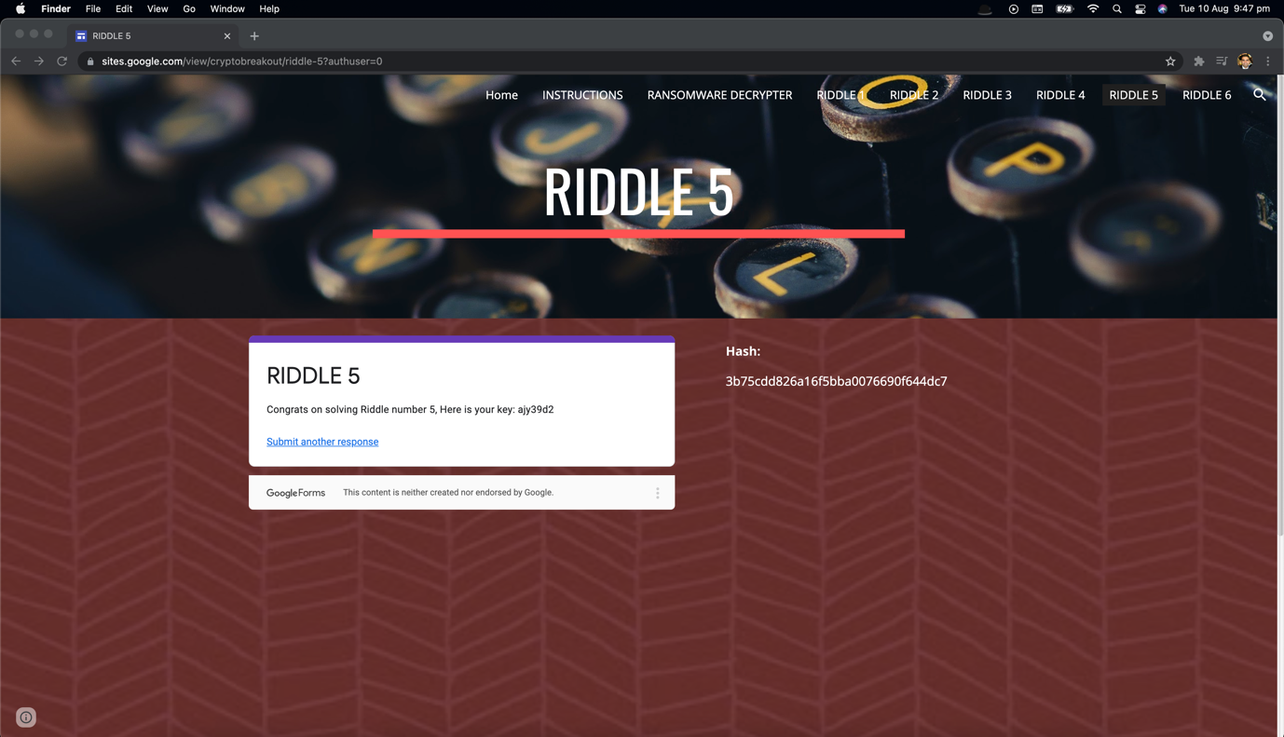



 **Riddle - 6**

**Answer: -** To solve Riddle 6, I have applied the command-line tool `steghide` to find the secret message. I download image into VM and run steghide command – **“steghide extract -sf mary-lamb.jpg”.**

**Below is the command syntax: -**

* `steghide` is the command to run `steghide`.
* `extract` is the additional command to indicate I am extracting the message.
* `-sf stands for _stegofile_, to specify which file to run the steganography tool against.

As its mention the passphrase was on the book (ABC), I entered **‘ABC’** and the data extracted to **"code_is_inside_this_file.txt"**, after open the file I got the password.

**Password – mcclane**

**Congrats on solving Riddle number 6, they key is: 7skahd6. Now go and enter in all of your keys into the Ransomware decrypter!!**

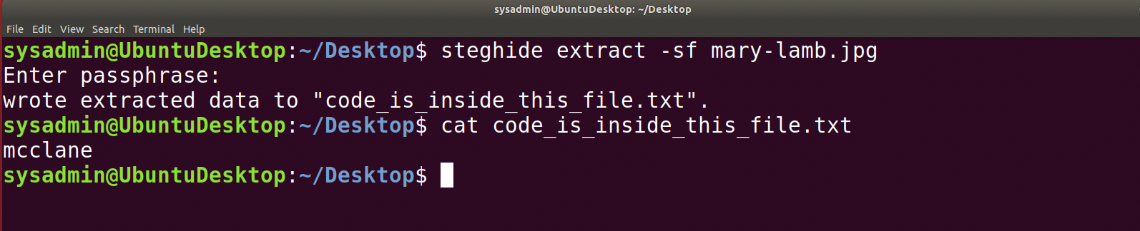

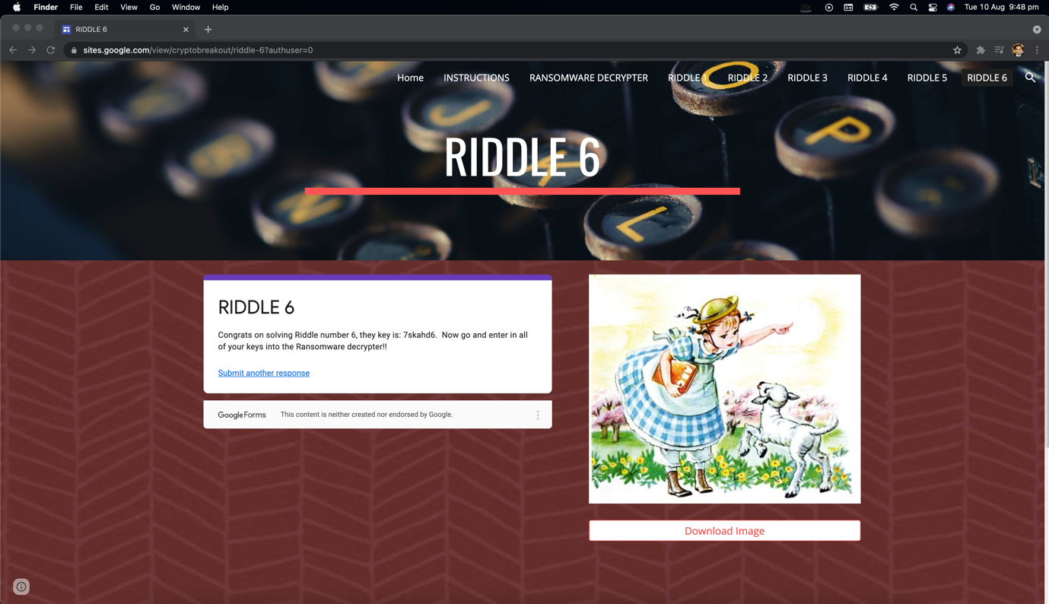



And finally, I have entered all of my keys into the Ransomware decrypted.

**RANSOMWARE DECRYPTER**

**Congratulations! You have decrypted the Ransomware! All the Nakatomi Hospital Records are now Decrypted! Please take a screenshot of this message and submit as your homework!**

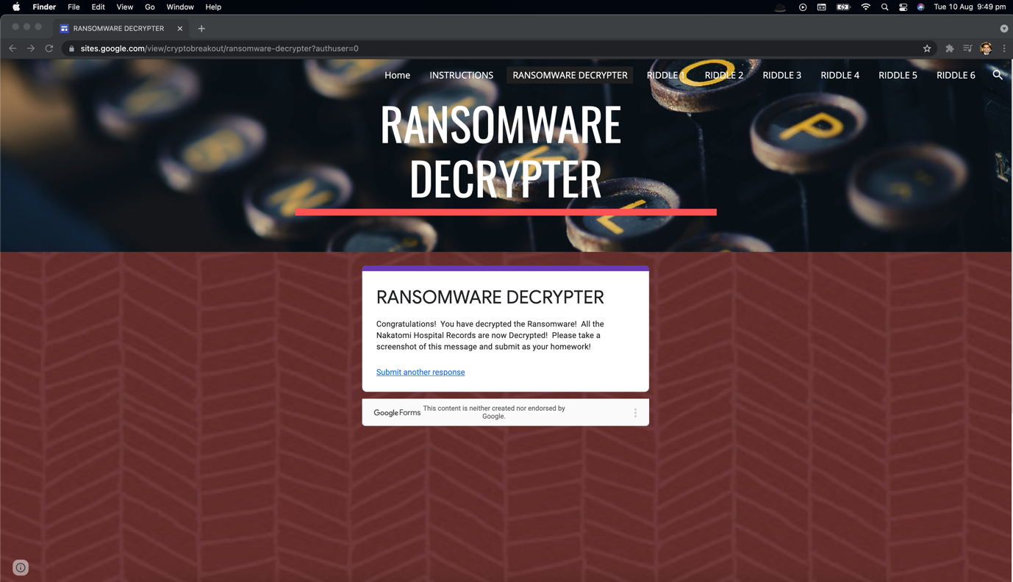

Below is the link for all Screen Shorts.

<https://drive.google.com/drive/folders/1nQytHxfilX26x9XSP8aPuhzG1lan2t7-?usp=sharing>

Kind regards,

Aziz Somani